📝 SOC Investigation Notes Template

🔹 Basic Information
- Incident ID: 8814
- Date: Jun 4th 2026 at 05:09
- Start Time: 6/4/2026, 4:10:36.095 AM
- Analyst: Yordan B.
- Severity: medium
- Alert Source: (Email)
- Alert Name/Rule: Inbound Email Containing Suspicious External Link

🔹 Initial Observation
What triggered this investigation?
This alert was triggered by an inbound email contains one or more external links due to potentially suspicious characteristics. As part of the investigation, check firewall or proxy logs to determine whether any endpoints have attempted to access the URLs in the email and whether those connections were allowed or blocked.

Initial suspicion:
Phishing
Is this likely a true positive?
☐ Yes X No ☐ Unsure

🔹 Scope Identification
Affected Host(s): N/A
Affected User(s): j.garcia@thetrydaily.thm
Sender Address: onboarding@hrconnex.thm
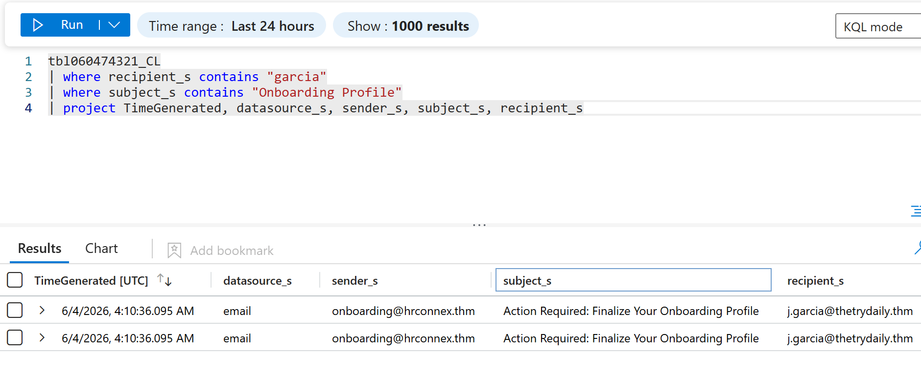

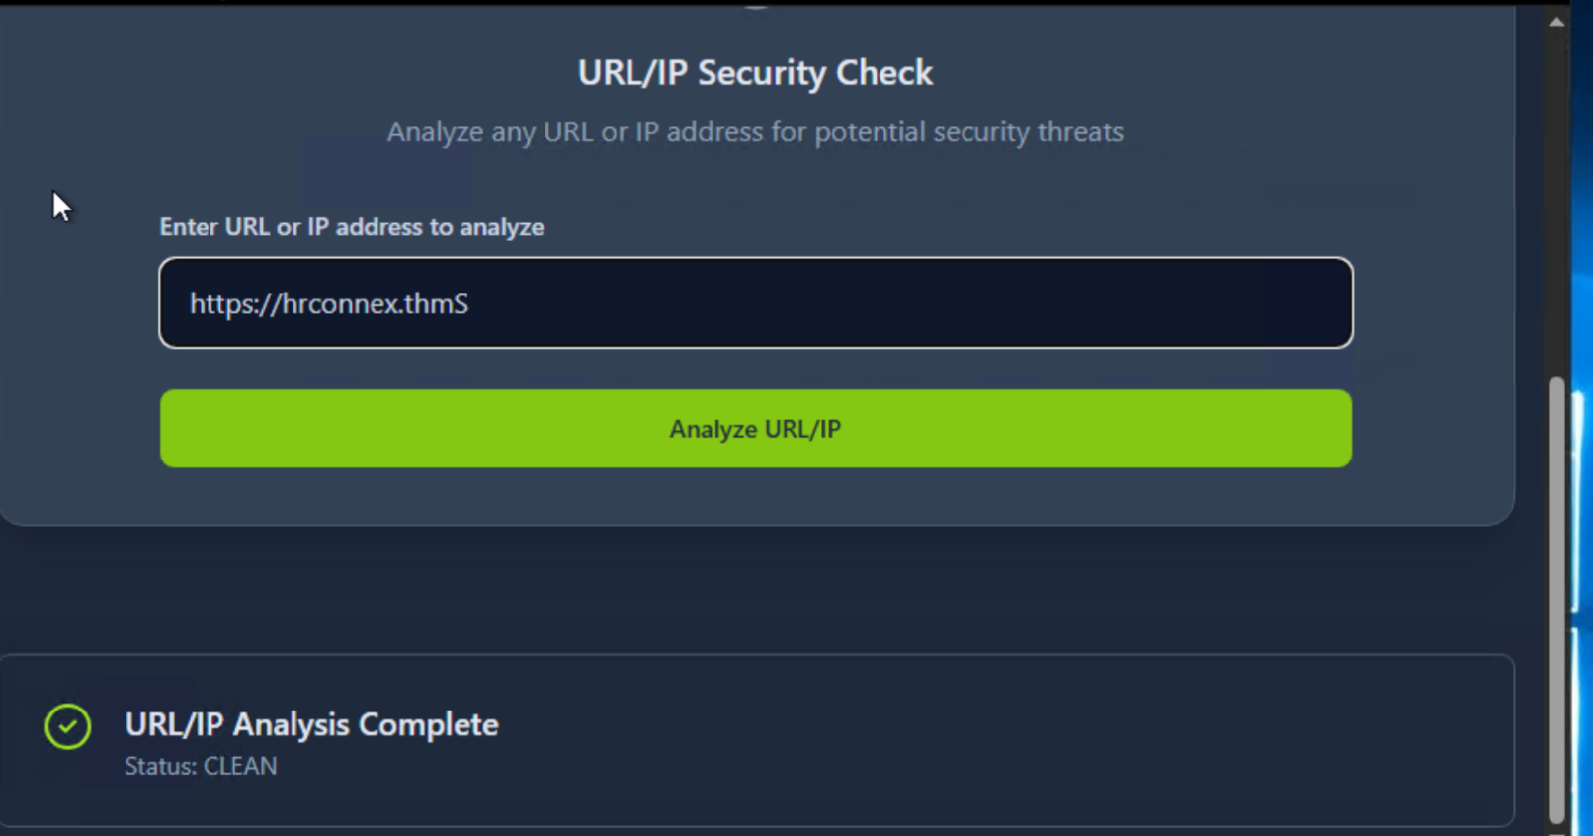
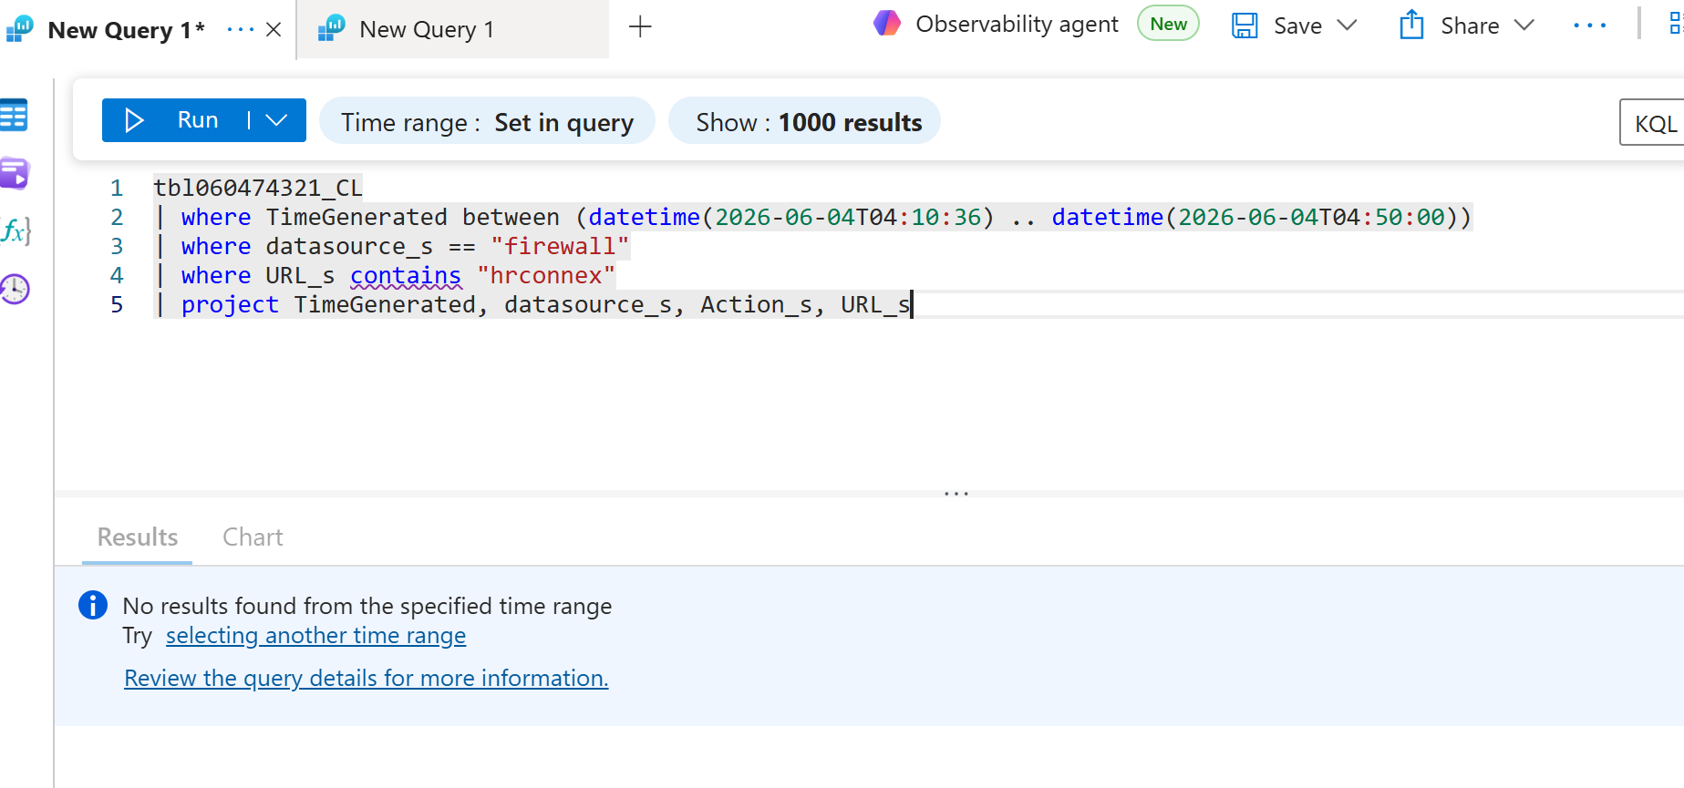

IP Address(es):
Domain(s)/URL(s): https://hrconnex.thm/onboarding/15400654060/j.garcia
File Hash(es):
Is this isolated or widespread?
☐ Single Host ☐ Multiple Hosts ☐ Unknown

Notes:

🔹 Key Findings Summary
- Email sent from [] to user [] cointingin link
- URL lnk in email not malicious as shown in URL scan Screen shot
- There is no activity showing the user clicked the link a shown in the KQL query ran

🔹 Containment Actions (Track in Real-Time)
☐ Host isolated
☐ Account disabled
☐ Password reset
☐ IP/domain blocked
☐ File removed
☐ Email quarantined
Other Actions: No action needed

🔹 Investigation Status
☐ Ongoing
☐ Contained
☐ Escalated
X Resolved

🔹 Root Cause (Working Theory)
[Update as you investigate]

🔹 Next Steps
- Tune alerts to reduce Alert fatigue cointaining False Positive.

🔹 Final Notes
AS Shown in Screenshots above, URl was not Malicious and alert was a false positive. Next steps will be tuning the alerts to reduce False positives on logs.

🔹 Post-Incident (Fill After Closure)
Confirmed Root Cause: False positive alerts on legitimate email.
Impact: None
Lessons Learned: Alerts needs to be tune.
Detection Gaps: No gaps in this incident
Recommendations: Alerts should be tuned in and monitored ona a weekly basis.

